SchulArena - Speaking Task: intelligent parrots

passend zu: Open World 1 Unit 3 / Communicative creatures (oder lehrmittelunabhängig einsetzbar)
- Download the document and save it on your computer.
- Print it out and bring it to class.
- Read the instruction carefully.

- Task: parrot intelligence (monologisches Sprechen)
Watch this youtube film and take notes:
http://www.youtube.com/watch?v=O_Fpad20Zbk&feature=related
Tell the others what the film was about. You can use your notes but do not read whole sentences from the paper.
These questions should help you to concentrate on the most important parts:
- What kind of animal is it?
- What are the names of the animals?
- What’s the animal’s ability? What can they do?
- Interesting facts about the animals?
- What’s the name of the animal’s owner?
- What do they want to find out?
- What experiments are they doing with the animal?
- What did the owner prove?
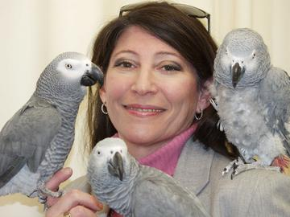
- What happened to the animal?

