SchulArena-Webquest: Giant constructions / Take a walk to some of the most famous buildings
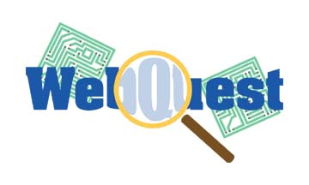
passend zu: Open World 1 Unit 2 / Design matters (oder lehrmittelunabhängig einsetzbar)
- Download the document and save it on your computer.
- Write the answers and/or post the pictures onto this sheet.
- Print it out when you have finished and bring it to class.

- Station one: Burj Khalifa
You need the following sites or software:
- Google Earth (download: http://www.google.de/intl/de/earth/index.html )
- http://www.burjkhalifa.ae/
- http://www.google.ch
Find the building on Google Earth and copy the picture from 2000m above sea level. Copy the picture into the rectangle and cut it to size.

Compare Burj Khalifa with other great towers and fill in this chart:
order | name: | city, nation: | height:
1
2
3
4
5
6

World ranking: Find a graphic which compares Burj Khalifa in world ranking with other buildings.

Find out more about Burj Khalifa:
- Which items are not allowed when you visit the observation deck? Underline them:
chewing gum, knife, sun cream, alcohol, glass bottle, laptop, skate shoes
- tonnes of steel: _____________ / m³ of concrete: _____________
- total man-hours of work: ________________ / construction time: __________ years
- entrance fee: you are 13 years old and you book in advance: _____ AED = _____ CHF
- height of the spire: ___________

- Station two: Golden Gate bridge
You need the following sites:
- http://www.goldengatebridge.org/
- http://www.google.ch

When did the Golden Gate bridge open? __________________________
How many workers died during the construction? __________
Can the bridge be crossed by pedestrians? yes no
Is it allowed to cross the bridge on roller blades? yes no
- Total length of bridge: ___________________
- Width of bridge: _________________
- Height of main towers above water: _____________________
- Total length of steel wire used in both main cables: _________________
- How much is the bridge toll for a normal car? ________________
- How many vehicles have crossed the bridge since its opening? _______________________

- Station three: The Cheops Pyramid

You need the following sites:
- http://en.wikipedia.org/wiki/Great_Pyramid_of_Giza
- http://www.google.ch

- Height of the pyramid: _____________________
- Year of construction: ________________________
- For How long was it the tallest building in the world? _________________
- Which building topped its height? _____________________
- Name of the Pharao: _______________________
- It is the ________________ of the ______________ ______________ of the Ancient World.
picture of the pyramid:

