
SchulArena - Speaking Task: Architecture
passend zu: Open World 1 Unit 2 / Design matters (oder lehrmittelunabhängig einsetzbar)
- Download the document and save it on your computer.
- Print it out and bring it to class.
- Read the instruction carefully.
- Task two: floor plan (monologisches Sprechen)
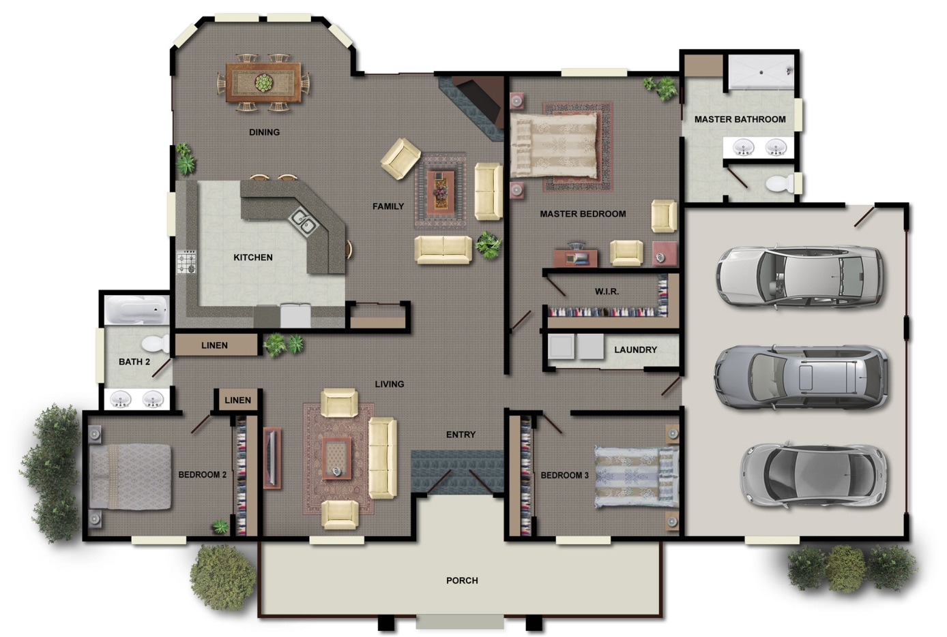
Have a look at this floor plan and prepare a short presentation. Describe the plan as detailed as possible.

