SchulArena - Speaking Task: Architecture

passend zu: Open World 1 Unit 2 / Design matters (oder lehrmittelunabhängig einsetzbar)
- Download the document and save it on your computer.
- Print it out and bring it to class.
- Read the instruction carefully.

- Task one: pictures (dialogisches Sprechen)
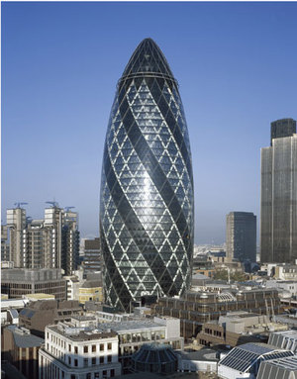
Have a look at these pictures and talk about them with your partner: materials, shapes, colours, design, city etc.
